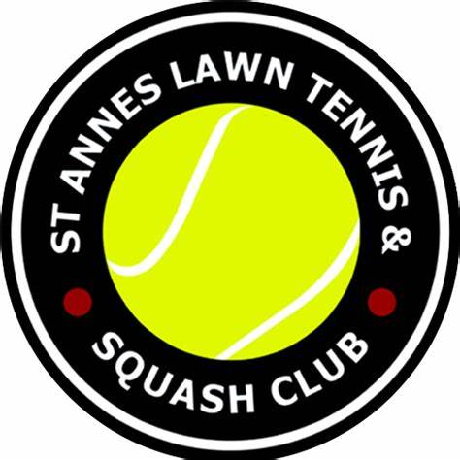 St.Annes Lawn Tennis and Squash club SAFEGUARDING POLICY AND PROCEDURES

VERSION 1.5 – JANUARY 2023
- Addition of contents page
- New reporting a concern flowcharts to bring in line with new LTA procedures
- Added responsibility for safeguarding within the venue
- Added details on recruitment and training
- Changed the code of conduct to Standards of Practice and Behaviour to refer to the LTA code of conduct in disciplinary code
- Added details on the definition of position of trust and that the law changed in 2022
- Added information about factors which increase vulnerability to abuse
- Added low level concerns definition and procedure
- Added requirements on confidentiality
- Added section on information sharing and retention of safeguarding related information
- Added section on mental capacity (adults at risk)
- Added section on making safeguarding personal (adults at risk)
- Added section on consent requirements for adults at risk
- Updated section on legislation
- Addition of support services

St.Annes lawn tennis and squash club Safeguarding Policy and Procedures
Contents
Policy Statement and Scope 3
Policy Principles 3
Responsibility for Safeguarding 4
Policy Aims 4
Definitions 5
Recruitment 5
Training 5
Code of Conduct 5
Transportation 6
Supervising Children 6
Positions of Trust 6
Types of Abuse 7
Increased Vulnerability to Abuse 7
Low Level Concerns 8
Responding to a Safeguarding Concern or Allegation 9
Responding to a Disclosure of Abuse 9
Making Safeguarding Personal 10
Mental Capacity 10
Confidentiality 11
Information Sharing and Retention 11
Whistleblowing 12
Related Policies and Guidance 12
Appendix A: Reporting a Safeguarding Concern That Occurs Within Tennis 14
Appendix B: Reporting a Safeguarding Concern That Happens Outside of Tennis 15
Appendix C: Definitions 16
Appendix D: Legislation, Guidance and Regulations 21
Appendix E: Additional Information and Support 22

Policy Owner: S. Robson
Policy approved by: St.Annes Lawn Tennis Committee
Date Policy approved:08.02.26
Next review Date:08.02.2029

POLICY STATEMENT AND SCOPE
St.Annes Tennis and Squash Club recognises our moral and statutory responsibility to safeguard and promote the welfare of all children (anyone under 18) and adults at risk. We are committed to ensuring our safeguarding practice reflects statutory responsibilities, government guidance and with LTA safeguarding standards, which can be found here: https://www.lta.org.uk/about-us/safeguarding/venue-standards/.

We are committed to prioritising the well-being of children and adults at risk and providing a safe and welcoming environment where they are respected and valued. We are alert to the signs of abuse and neglect and follow our procedures to ensure that children and adults at risk receive effective support and protection.

We recognise that health, well-being, ability, disability and need for care and support can affect a person’s resilience. We recognise that some people experience barriers, for example, to communication in raising concerns or seeking help. We recognise that these factors can vary at different points in people’s lives.

We recognise that there is a legal framework within which sport needs to work to safeguard adults at risk and will act in accordance with the relevant safeguarding adult legislation and with local statutorysafeguardingprocedures.
Actions taken by us will be consistent with the principles of adult safeguarding ensuring that any action taken is prompt, proportionate and that it includes and respects the voice of the adult concerned.

This policy applies to any person who plays, coaches, officiates, works, volunteers, or otherwise participates (or visits) at our venue.

We expect contractors and partner organisations, including for example, suppliers and sponsors to adopt and demonstrate their commitment to the principles and practice as set out in this Policy and associated procedures.

All bound by this policy are responsible for upholding high standards of conduct and professionalism and raising safeguarding concerns and allegations in accordance with the Reporting a Safeguarding Concern Procedures.

Gillian McGuinness  Chairperson | Sarah Robson  Welfare Officer

POLICY PRINCIPLES
- The safety and welfare of children and adults at risk is paramount
- All children and adults at risk, regardless of age, disability, gender reassignment, race, religion or belief, sex, or sexual orientation have an equal right to protection from all types of harm or abuse
- Safeguarding is everybody’s responsibility
- All safeguarding concerns or allegations will be taken seriously and responded to swiftly and appropriately
- We strive to create a culture and environment where everyone is empowered to protect themselves and others and feel able to raise concerns
- We actively promote working together to ensure all children and adults at risk are safeguarded

RESPONSIBILITY FOR SAFEGUARDING
The Committee have overall accountability for this policy and its implementation.

We have an appointed Welfare Officer (WO) who holds operational responsibility for safeguarding in line with the LTA role profile and is supported by the Committee. The WO is the first point of contact to raise a safeguarding concern involving a child or adult at risk. They also play a proactive role in increasing an awareness of safeguarding within our venue.

The Welfare Officer is:
[Name: Sarah Robson
Contact number07483162830
Email address: stanneswelfareofficer@gmail.com

If the Welfare Officer is not available to report a safeguarding concern or allegation to, the alternative contact within our venue is:
[Name Gillian McGuinness
Contact number: 07483162830
Email address:stannesltsc@gmail.com

The LTA Safeguarding Team has strategic and operational responsibility for safeguarding in tennis in Britain, including the monitoring and evaluation of safeguarding standards and investigating safeguarding concerns. Safeguarding concerns can be raised directly to the LTA Safeguarding Team via https://safeguardingconcern.lta.org.uk/

The Local Authority contact details are:
Children Services:03001236720
Adult Services: 03001236720 or 03001236722

All bound by this policy are responsible for raising safeguarding concerns in accordance with the ‘Reporting a safeguarding concern’ procedure (see Appendix A and B).

POLICY AIMS
The purpose of this policy is to:
- Protect children (including children of adults who use our services) and adults at risk from harm
- Provide the necessary information to enable people to meet their safeguarding responsibilities
- Deliver good practice and high safeguarding standards
- Outline our commitment to safeguarding children and adults at risk

DEFINITIONS
Child: anyone under the age of 18.

Parent: birth parents and other adults who are in a parenting role.

Adult at risk:

England (Care Act 2014) | Scotland (Adult Support and Protection Act 2007) | Wales (Social Services and Well Being Act 2014)
An individual aged 18 years and over who:  - has needs for care and support (whether or not the local authority is meeting any of those needs) and;  - is experiencing, or at risk of, abuse or neglect, and;  - as a result of those care and support needs is unable to protect themselves from either the risk of, or the experience of abuse or neglect. | An individual aged 16 years and over who:  - is unable to safeguard their own well-being, property, rights or other interests,  - is at risk of harm, and  because they are affected by disability, mental disorder, illness or physical or mental infirmity, is more vulnerable to being harmed than adults who are not so affected. | An individual aged 18 years and over who:  - is experiencing or is at risk of abuse or neglect, and;  - has needs for care and support (whether or not the authority is meeting any of those needs) and;  - as a result of those needs is unable to protect himself or herself against the abuse or neglect or the risk of it.

RECRUITMENT
We operate a Safe Recruitment Policy and are committed to ensuring that people who work (including volunteers and self-employed individuals who we engage) with children or adults at risk are appropriately qualified for that role. This means that, where necessary, they will be required to undergo Criminal Records Checks through the Disclosure and Barring Service (DBS) in England and Wales, the Protection Vulnerable Groups (PVG) Scheme for those in Scotland, or the equivalent Overseas Criminal Records Check in their country of origin before being allowed to work.

TRAINING
All LTA Accredited Coaches and Welfare Officers complete safeguarding training as part of their role and renew this as part of their Accreditation requirements or every three years. The Committee also receive safeguarding training (every three years or when there are changes to the Committee) provided to them via the Welfare Officer to enable them to recognise the possible signs and indicators of abuse and what to do if they have a safeguarding concern or allegation.

An induction, which includes our safeguarding policies and procedures, reporting and recording arrangements, and details for the Welfare Officer, is also provided to all new staff, volunteers, coaches and any self-employed individuals who we engage.

Code of Conduct
All individuals within scope of this policy are expected to familiarise themselves with this policy and the LTA Code of Conduct (available here: https://www.lta.org.uk/about-us/what-we-do/governance-and-structure/rules-regulations/), and at all times act in accordance with them. Breaches of the law, this Policy and/or the LTA Code of Conduct may result in criminal and/or disciplinary action being taken.

TRANSPORTATION
It is the responsibility of parents to ensure appropriate transport arrangements are in place for their children when travelling to and from the venue. Similarly, it is the responsibility of the adult at risk (or their carer) to ensure transport arrangements are in place.

Coaches and other staff/volunteers are not responsible for transporting children or adults at risk to and from the venue or other locations (except if it is an emergency), unless it is as part of a venue organised trip in which case the following measures will be in place
- The adult at risk or child’s parents are informed of the destination, reason for the journey and who the driver will be
- The adult at risk or child’s parents return a completed consent form and the driver will have a copy of this and emergency contact details during the journey
- There will be two adults in the front of the car, irrespective of the number of children or adults at risk being transported.
- Children or adults at risk are always seated in the back of the vehicle
- If there is a mixture of female and male children or adults at risk, we will seek to have adults of matching gender where possible
- There is an established procedure in the event of a breakdown/emergency.
- The driver has a valid UK driving license, DBS/PVG, correct insurance, MOT certificate and complies with laws on the use of seatbelts and restraints

SUPERVISING CHILDREN
Children under the age of 12 are required to have parental supervision whilst at our venue and not participating in any venue sessions, such as coaching lessons or tennis camps.

For coaching activities, we comply with the LTA guidance on coach-to-player ratios. For children aged under 12, children must be delivered directly into the care of the coach by the parent and picked up directly from the coach. Please note that it is not enough to drop off outside or at the front door of the venue. Parents must ensure that their child has been delivered to the coach. Children under the stipulated age will not be allowed to leave a coaching session or camp unattended unless permission has been given in writing.

For other activities, e.g. away trips/matches, we will use the following adult-to-child ratios:
- 2:8 for children 10 and under
- 2:10 for children aged 11 and over

We may decide to have a greater adult-to-child ratio dependent on the needs of the children or identified risks. At least one of the supervising adults will, where possible, be the same gender as the children. Situations where a child has to leave a venue session, for example, to use the toilet, will also be supervised.

POSITIONS OF TRUST
A person aged 18 or older who holds a position of authority or responsibility over a child or adult at risk is in a position of trust. Positions of trust are not defined by a qualification or job title, but by reference to the activity which the adult is carrying out in relation to the child or adult at risk, namely, coaching, teaching, training, supervising or instructing (including as a volunteer) on a regular basis. People who are in a position of trust must be aware of the power imbalance they hold over children and adults at risk and not use this for personal advantage or gratification.

In June 2022, the Sexual Offences Act 2003 was changed to extend the abuse of position of trust offences to include where an adult is coaching, teaching, training, supervising or instructing a child under 18 years old within sport or religious settings. This means that under the Sexual Offences Act 2003, in England and Wales it is a criminal offence for a person in a position of trust to have a sexual or intimate relationship with a child under 18 years old, even if the relationship is deemed consensual. Therefore, any sexual activity (including online activity) between someone in a position of trust and a child under 18 years old will be formally reported as it may be a criminal offence.

TYPES OF ABUSE
There are four main types of abuse that apply to children, these being:
- Sexual
- Physical
- Emotional
- Neglect

The safeguarding adults at risk legislation in each home nation defines categories of adult abuse and harm as follows.

England (Care Act 2014) | Wales (Social Services and Well Being Act 2014) | Scotland (Adult Support and Protection Act 2007)
Physical  Sexual  Emotional/Psychological/Mental  Neglect  Financial or material abuse  Discriminatory  Organisational  Self-neglect  Domestic Abuse (including coercive control)  Modern slavery | Physical  Sexual  Psychological  Neglect  Financial | Physical  Psychological  Financial  Sexual  Neglect

Detailed descriptions of these types of abuse, along with other forms of harm, can be found in (Appendix C).

INCREASED VULNERABILITY TO ABUSE
Vulnerability is a changeable and contextual state but may include children and adults at risk with a physical disability or diagnosed condition such as dementia, learning difficulties, or those who have a mental health condition such as severe anxiety or depression. Children and adults in these groups may:
- Have smaller network of friends and peer group to support and protect
- Require intimate/physical and or invasive medical care required which can allow abuse to be hidden
- Have communication difficulties
- Be less able to resist either verbally or physically
- Be dependent on the abuser for a service or basic need
- Have medical conditions that are used to explain injuries

Personal circumstances away from tennis or squash such as domestic violence, poverty, substance abuse, homelessness and social exclusion may also have an impact on vulnerability. In addition, children and adults at risk from LGBTQ+ and/or Black, Asian and Other Minority Ethnic groups can:
- Be subjected to bullying, emotional abuse and physical abuse due to their sexual orientation or gender identity
- Experience racism and racist attitudes
- Engage in cultural practices, which are classed as abuse within the UK (e.g., honour-based violence, female genital mutilation)
- Expect to be ignored by people in authority due to experience of institutionalised racism
- Be afraid of further abuse or racist abuse if they challenge others
- Be subjected to myths based on racial stereotyping
- Be using or learning English as a second language and therefore find it more difficult to communicate

Elite athletes may also be more vulnerable to abuse because they may:
- Have increased dependency on coaching and other support staff for funding, selection and progression
- Be segregated from protective factors such as their family and peer groups
- Feel less able to report concerning behaviour due to a fear of impacting their sporting development
- Be exposed to unhealthy cultures and competitive performance ideologies, where inappropriate practices may be accepted or even encouraged under the belief they deliver success
- Be subjected to intense training and pressure to play/succeed even when injured and achieve unrealistic image, body and weight expectations

LOW LEVEL CONCERNS
A low level concern (which can also be known as poor practice) is behaviour that falls short of abuse towards a child and does not meet the allegation threshold or a referral to the Local Authority Designated Officer (LADO, England and Wales only), but which nevertheless harms or places a child at risk of harm or has a negative effect on the safety and well-being of children.

An ‘allegation’ means that it is alleged that a person who works with children has:
- Behaved in a way that has harmed a child or may have harmed a child
- Possibly committed a criminal oﬀence against a child
- Behaved towards a child or children in a way that indicates they may pose a risk of harm to children
- Have behaved in a way in their personal life that raises safeguarding concerns. These concerns do not have to directly relate to a child but could, for example, include an arrest for possession of a weapon
- Have, as a parent or carer, become subject to child protection procedures

A low level concern is any concern - no matter how small, and even if no more than a ‘nagging doubt’ - that an adult may have acted in a manner which:
- Is not consistent with the Code of Conduct, and/or
- Relates to their conduct outside of work which, even if not linked to a particular act or omission, has caused a sense of unease about that adult’s suitability to work with children

Low level concerns are not acceptable and should be reported to the Venue Welfare Officer who will refer the matter on to the LTA Safeguarding Team and/or Squash England. It is critical that all low level concerns are referred to the LTA and/or Squash England.. Having one recipient of all such concerns should allow any potential patterns of concerning, problematic or inappropriate behaviour to be identified, and ensure that no information is potentially lost.

Upon receipt by the LTA, low level concerns will be triaged and managed through the LTA Safeguarding Regulations, which form part of the LTA Disciplinary Code available here: https://www.lta.org.uk/about-us/what-we-do/governance-and-structure/rules-regulations/.

The LTA and/or Squash England. may decide that the low level concern is suitable to be dealt with by the venue directly, in which case the LTA will support them with managing the situation. If further information comes to light which raises the level of concern, the matter must be referred to the LTAand/or Squash England. .

RESPONDING TO A SAFEGUARDING CONCERN OR ALLEGATION
Everyone has a responsibility to ensure the safety and welfare of children and adults at risk and to take appropriate steps to ensure that safeguarding concerns and allegations are taken seriously and responded to quickly and appropriately, even if the safeguarding concern or allegation may not have occurred recently.

It is advisable to discuss safeguarding concerns or allegations with the adult at risk, or the child’s parents in the first instance except where this may place the adult at risk, a child, or someone else, at increased risk.

It is not the responsibility of anyone within the venue to investigate any safeguarding concern or allegation, nor determine whether abuse has taken place. All concerns must be responded to in accordance with the Reporting a Safeguarding Concern Procedure.

Once a safeguarding concern or allegation is reported to our Welfare Officer, it will be passed onto the LTAand/or Squash England. Safeguarding Team who will triage and manage it through the LTA Safeguarding Regulations, which form part of the LTA Disciplinary Code available here: https://www.lta.org.uk/about-us/what-we-do/governance-and-structure/rules-regulations/.

RESPONDING TO A DISCLOSURE OF ABUSE
If a child or adult at risk discloses that he or she has been abused or is at risk of abuse:
- Listen carefully and calmly to what is said
- Reassure them that they have done the right thing and what they have told you is very important
- Keep questions to a minimum, only ask questions if you need to identify/ clarify what the person is telling you
- Ask them what they would like to happen next
- Explain what you would like to do next
- Ask for their consent for the information to be shared (adults only)
- Let them know that you will need to speak to the Welfare Officer/LTA and/or Squash England.Safeguarding Team because it is in their best interest. If you intend to speak to the police or social care, you should let them know this too.
- Do not seek to investigate it yourself or let doubt/personal bias prevent you from reporting the allegation
- Make an arrangement as to how you can contact them safely (adults only)
- Help them to contact other organisations for advice and support (e.g. Police, Domestic Abuse helpline, Victim Support, etc)
- Ensure that their immediate needs are met and that the priority is their safety and protection from further risk of harm
- Record details of the disclosure (further advice here) as soon as possible (but not during the disclosure) and then submit the details to the LTA and/or Squash England. via https://safeguardingconcern.lta.org.uk/

MAKING SAFEGUARDING PERSONAL
Legislation recognises that adults make choices that may mean that one part of their well-being suffers at the expense of another. Similarly, adults can also make a decision to risk their personal safety, for example to provide care to a partner with dementia who becomes abusive when they are disorientated and anxious.

The concept of ‘well-being’ is threaded throughout UK legislation and is part of the Law about how health and social care is provided. Our well-being includes our mental and physical health, our relationships, our connection with our communities and our contribution to society.

’Making Safeguarding Personal’ means engaging an adult at risk in a conversation about how best to respond to their situation in a way that enhances their involvement, choice and control, as well as improving their quality of life, well-being and safety. Their views, wishes, feelings and beliefs will be taken into account when decisions are made about how to support them to be safe and finding the solution that is right for them. Treating people with respect, enhancing their dignity and supporting their ability to make decisions also helps promote people's sense of self-worth and supports recovery from abuse.
If an adult at risk has difficulty making their views and wishes known, they can be supported or represented by an advocate. This might be a safe family member or friend of their choice or a professional advocate (usually from a third sector organisation).

Being able to live free from abuse and neglect is a key element of well-being. Any actions taken to safeguard an adult must take their whole well-being into account and be proportionate to the risk of harm.

MENTAL CAPACITY
It is important to make sure an adult at risk has choices in the actions taken to safeguard them, including whether or not they want other people informed about what has happened, however, in some situations the adult may not have the mental capacity to understand the choice or to tell us their views.

If we are concerned that an adult at risk who has a lot of difficulty making their own decisions is being abused or neglected, we will need to refer the situation to the Local Authority, and this should result in health or social care professionals making an assessment of mental capacity and/or getting the person the support they need to make decisions.

We will always seek to obtain the consent from an adult at risk before sharing information about them with others, however there are some circumstances where we will need to act without their consent and these include where:
- it is not safe to contact them to gain their consent – i.e. it might put them or the person making contact at further risk
- we believe they or someone else is at risk, including children
- we believe the adult at risk is being coerced or is under duress
- it is necessary to contact the police to prevent a crime, or to report that a serious crime has been committed
- the adult at risk does not have mental capacity to consent to information being shared about them
- the person causing harm has care and support needs
- the concerns are about an adult at risk living in Wales or Northern Ireland (where there is a duty to report to the Local Authority).
When information is shared without the consent of the adult at risk this will be explained to them, when it is safe to do so, and any further actions should still fully include them

CONFIDENTIALITY
All safeguarding concerns and allegations will be dealt with confidentiality by the Welfare Officer on a need to know basis, not only to maintain the privacy of the individuals involved but also to ensure that evidence or any investigation is not compromised. All people involved in a safeguarding concern or allegation should similarly ensure they maintain high levels of confidentiality.

There may be circumstances where an individual raising a safeguarding concern or allegation does not wish to be named. It is not possible to assure anonymity, as in some circumstances individuals will need to be named (for example, where it is necessary in order to carry out a fair disciplinary process).

INFORMATION SHARING AND RETENTION
We share safeguarding information with the LTA and/or Squash England. in accordance with this policy and LTA regulations. In certain situations, we may be required to also share information with statutory agencies and other relevant organisations where it is considered necessary and proportionate to prevent or manage the risk of harm in tennis or sport to children.

We follow the UK Government’s Information Sharing Advice for Safeguarding Practitioners which describes the ‘7 Golden Rules’ of information sharing:
- Remember that the Data Protection Act 2018 and human rights law are not barriers to justified information sharing but provide a framework to ensure that personal information about living individuals is shared appropriately.
- Be open and honest with the individual (and/or their family where appropriate) from the outset about why, what, how and with whom information will, or could be shared, and seek their agreement, unless it is unsafe or inappropriate to do so.
- Seek advice from other practitioners if you are in any doubt about sharing the information concerned, without disclosing the identity of the individual where possible.
- Share with informed consent where appropriate and, where possible, respect the wishes of those who do not consent to share confidential information. You may still share information without consent if, in your judgement, there is good reason to do so, such as where safety may be at risk.
- Consider safety and well-being: Base your information sharing decisions on considerations of the safety and well-being of the individual and others who may be affected by their actions.
- Necessary, proportionate, relevant, adequate, accurate, timely and secure: Ensure that the information you share is necessary for the purpose for which you are sharing it, is shared only with those individuals who need to have it, is accurate and up-to-date, is shared in a timely fashion, and is shared securely.
- Keep a record of your decision and the reasons for it – whether it is to share information or not. If you decide to share, then record what you have shared, with whom and for what purpose.

Further details of the above guidance: https://www.gov.uk/government/publications/safeguarding-practitioners-information-sharing-advice.

When sharing safeguarding information, we will keep a dated record of:
- what has been shared;
- with whom; and
- for what purpose.

This should include, where applicable, a record of any steps taken to secure, protect or minimise personal data, any express limitations placed on the onward use of the information, and a record of the basis for sharing.

Where safeguarding information is concerned, we operate in line with best practice which is for long term (e.g. lifetime) retention of relevant documentation.

WHISTLEBLOWING
Whistleblowing is when someone reports wrongdoing on the basis that it is in the public interest for the wrongdoing to be brought to light. This can include:
- your or another organisation doesn’t have clear safeguarding procedures to follow
- concerns aren’t dealt with properly or may be covered up
- a concern that was raised hasn’t been acted upon
- you are worried that repercussions are likely to arise if you raise a concern.

This applies to incidents that happened in the past, are happening now, or may happen in the future.

Whistleblowers should contact the Welfare Officer in the first instance. If the whistleblower does not wish to speak to someone within the venue or the LTA Safeguarding Team, the NSPCC Whistleblowing advice line can be contacted on 0800 028 0285 or by emailing help@nspcc.org.uk.

Safecall is an independent, confidential and, if required, anonymous reporting service provided by the LTA if there are serious concerns regarding any of the public interest areas below:
- Criminal offences, including fraud
- Failure to comply with a legal obligation
- Legal miscarriage of justice
- Endangering someone’s health and safety
- Damage to the environment
- Covering up wrongdoing in any of the above categories

If a Whistleblower feels that it is not appropriate to contact the LTA Safeguarding Team on the grounds of one of the above areas, they can contact Safecall via telephone on 0800 915 1571. Calls are not recorded. Alternatively, a report can be made online: www.safecall.co.uk/report

RELATED POLICIES AND Procedures
This policy should be read alongside our other policies and procedures, including:
- Anti-Bullying
- Code of conduct
- Diversity and inclusion
- Online safety and communication
- Photography and filming
- Use of changing rooms
- Safeguarding at events, activities and competitions
- Safe recruitment

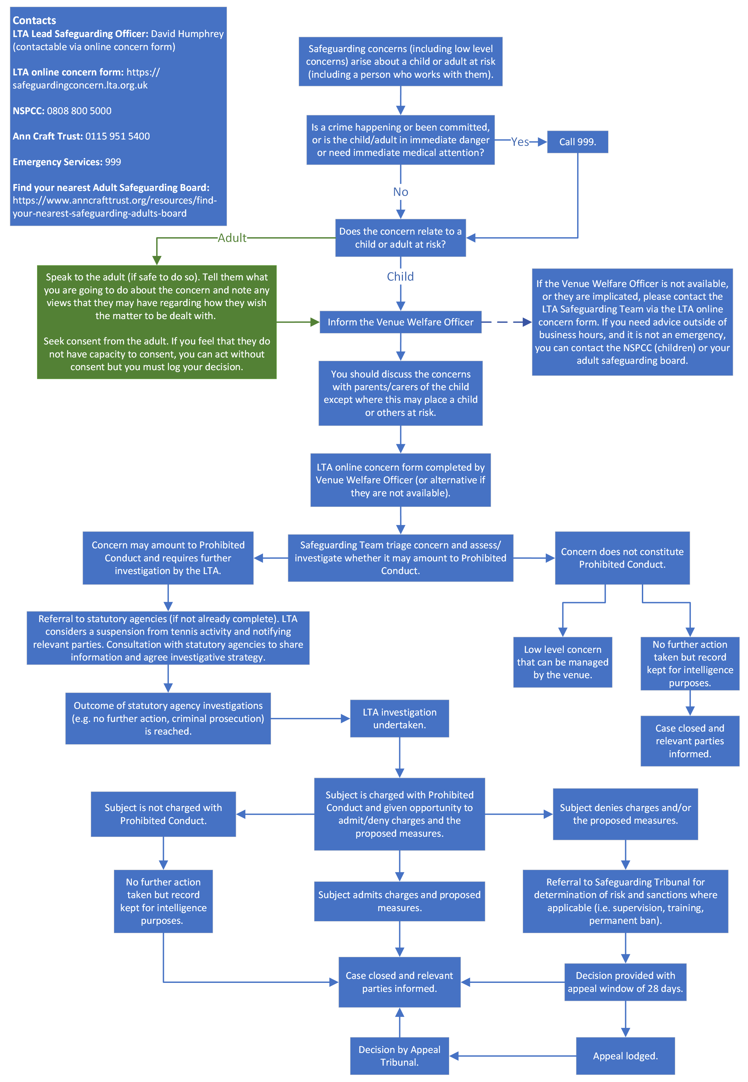
APPENDIX A: REPORTING A SAFEGUARDING CONCERN THAT OCCURS WITHIN TENNIS

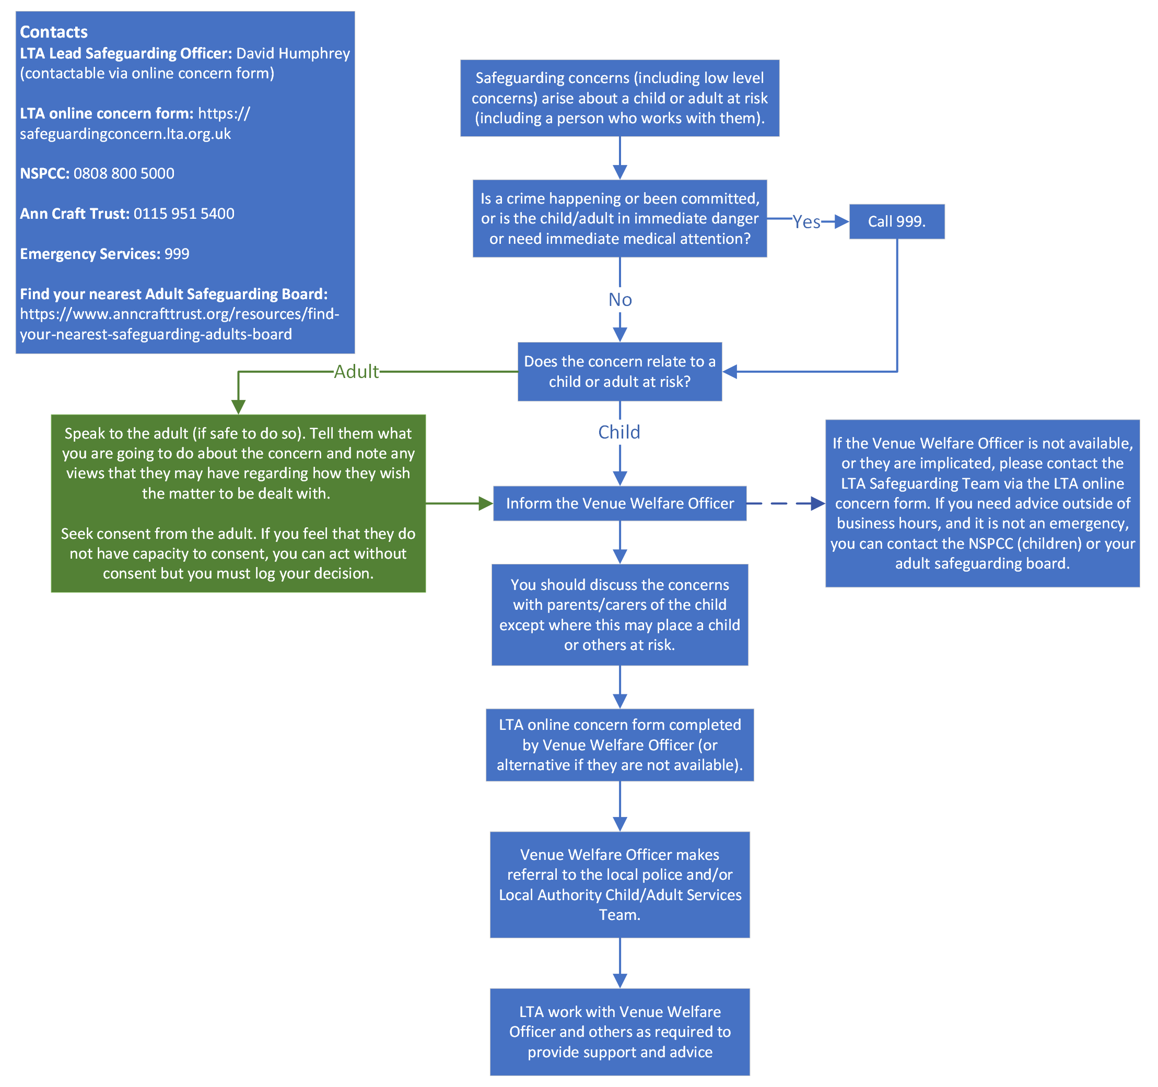
APPENDIX B: REPORTING A SAFEGUARDING CONCERN THAT HAPPENS OUTSIDE OF TENNIS

APPENDIX C: DEFINITIONS

Adult: a person aged 18 years or older

Child: a person under the age of 18 years.

Parent: birth parents and other adults who are in a parenting role.

Adult at risk:
In England, an individual aged 18 years and over who:
- has needs for care and support (whether or not the local authority is meeting any of those needs) AND;
- is experiencing, or at risk of, abuse or neglect, AND;
- as a result of those care and support needs is unable to protect themselves from either the risk of, or the experience of abuse or neglect.

In Scotland, an individual aged 16 years and over who:
- is unable to safeguard their own well-being, property, rights or other interests,
- is at risk of harm, AND;
- because they are affected by disability, mental disorder, illness or physical or mental infirmity, is more vulnerable to being harmed than adults who are not so affected.

In Wales, an individual aged 18 years and over who:
- is experiencing or is at risk of abuse or neglect, AND;
- has needs for care and support (whether or not the authority is meeting any of those needs) AND;
- as a result of those needs is unable to protect himself or herself against the abuse or neglect or the risk

Safeguarding: the action taken to promote the welfare of children and protect them from harm. This means protecting children from abuse and maltreatment, preventing harm to their health or development, ensuring they grow up with the provision of safe and effective care, and taking action to enable all children to have the best outcomes. Safeguarding adults means protecting a person’s right to live in safety, free from abuse and neglect.

Child protection: the processes undertaken to protect children who have been identified as suffering, or being at risk of suffering, significant harm.

Local Authority Designated Officer (LADO): an individual within a local authority in England and Wales with responsibility for oversight of allegations against people who work with children.

Prohibited conduct: engage, or attempt or threaten to engage, in conduct that directly or indirectly harms the physical and/or mental welfare and/or safety of one or more child or adult at risk; or pose a risk of harm to the physical and/or mental welfare and/or safety of one or more child or adult at risk.

Abuse: Abuse happens when a person harms a child or an adult at risk. An abuser can be:
- family members
- friends
- people working or volunteering in organisational or community settings
- people they know
- strangers

Indicators of abuse: There are many signs and indicators that may suggest a child or adult at risk is being abused or neglected. The NSPCC and Ann Craft Trust have comprehensive lists of the types of abuse and their indicators at: https://www.nspcc.org.uk/what-is-child-abuse/types-of-abuse/ and https://www.anncrafttrust.org/resources/types-of-harm/. Examples of signs and symptoms include but are not limited to:
- Unexplained change in behaviour
- Unexplained bruises or injuries
- Missing belongings or money
- Child is not attending / no longer enjoying their sessions
- Changes in weight
- Truancy
- Sexually explicit knowledge or behaviour
- Being withdrawn
- Genital pain, stomach pains, discomfort, pregnancy, incontinence, urinary infections, STDs.
- Dirty, ill-fitting clothes or a lack of appropriate clothing for the weather
- Self-harm.
- A fear of a particular group of people or individual.
- Lack of friends
- Lack or growth or development
- Low self-esteem

Neglect:
Children - Ongoing failure to meet the basic needs of children. Neglect may involve failing to provide adequate food or shelter including exclusion from home or abandonment, failing to protect them from physical and emotional harm or danger or failing to ensure access to appropriate medical care or treatment. It may also include neglect of, or unresponsiveness to, basic emotional needs.

Adults at risk - includes ignoring medical or physical care needs and failing to provide access to appropriate health social care or educational services. It also includes the withdrawing of the necessities of life, including medication, adequate nutrition, and heating.

Emotional abuse: Any act or other treatment which is persistent and may cause emotional damage and undermine a child’s sense of wellbeing. This includes persistent criticism, denigration or putting unrealistic expectations on children, isolation, verbal assault, humiliation, blaming, controlling, intimidation or use of threats.

Emotional/Psychological abuse (adults at risk): Includes threats of harm or abandonment, deprivation of contact, humiliation, blaming, controlling, intimidation, coercion, harassment, verbal abuse, isolation, or withdrawal from services or supportive networks.

Physical abuse:
Children - Physical abuse happens when a child is deliberately hurt, causing physical harm. It can involve hitting, kicking, shaking, throwing, poisoning, burning or suffocating. It’s also physical abuse if a parent or carer makes up or causes the symptoms of illness in children. For example, they may give them medicine they don’t need, making them unwell. This is known as fabricated or induced illness (FII).

Adults at risk - Hitting, slapping, pushing, kicking, misuse of medication, restraint, or inappropriate sanctions.

Sexual abuse:
Children - Any act which involves forcing or enticing a child to take part in sexual activities. It doesn’t necessarily involve violence and the child may not be aware that what is happening is abuse. The activities may involve physical contact, including assault by penetration (for example, rape or oral sex) or non-penetrative acts such as masturbation, kissing, rubbing and touching outside of clothing.

They may also include non-contact activities, such as involving children in looking at, or in the production of, sexual images, watching sexual activities, encouraging children to behave in sexually inappropriate ways, or grooming a child in preparation for abuse. Sexual abuse can take place online, and technology can be used to facilitate offline abuse. Sexual abuse is not solely perpetrated by adult males. Women can also commit acts of sexual abuse, as can other children.

Abusers may threaten to send sexually explicit images, video or copies of sexual conversations to the child’s friends and family unless they take part in other sexual activity. Images or videos may continue to be shared long after the abuse has stopped.

Adults at risk - Includes rape, indecent exposure, sexual harassment, inappropriate looking or touching, sexual teasing or innuendo, sexual photography, subjection to pornography or witnessing sexual acts, indecent exposure and sexual assault, or sexual acts to which the adult has not consented, or was pressured into consenting.

Grooming: The process of developing a relationship with and the trust of a child, their family, and any other adults around the child, to commit sexual abuse or exploitation against them. Grooming can happen both online and in person.

Child sexual exploitation: A form of child sexual abuse. It occurs where an individual or groups of people take advantage of an imbalance of power to coerce, manipulate or deceive a child into sexual activity in exchange for something the victim needs or wants and/or for the financial advantage or increased status of the perpetrator or facilitator. The victim may have been sexually exploited even if the sexual activity appears consensual. Child sexual exploitation can also take place through the use of technology.

Self-neglect (adults at risk): Covers a wide range of behaviour, but it can be broadly defined as neglecting to care for one’s personal hygiene, health, or surroundings. An example of self-neglect is behaviour such as hoarding.

Modern Slavery (adults at risk): Encompasses slavery, human trafficking, forced labour, and domestic servitude.

Domestic Abuse (adults at risk): Domestic abuse is any type of controlling, coercive, threatening behaviour, violence or abuse between people who are, or who have been in a relationship, regardless of gender or sexuality. It can include physical, sexual, psychological, emotional or financial abuse.

Exposure to domestic abuse is child abuse. Children can be directly involved in incidents of domestic abuse or they may be harmed by seeing or hearing abuse happening. Children in homes where there is domestic abuse are also at risk of other types of abuse or neglect.

Discriminatory (adults at risk): Abuse or bullying because of discrimination occurs when motivated by a prejudice against certain people or groups of people. This may be because of an individual’s ethnic origin, colour, nationality, race, religion or belief, gender, gender reassignment, sexual orientation or disability. Actions may include unfair or less favourable treatment, culturally insensitive comments, insults and ‘banter’.

Organisational (adults at risk): Includes neglect and poor care practice within an institution or specific care setting, such as a hospital or care home, or in relation to care provided in one’s own home. Organisational abuse can range from one off incidents to ongoing ill-treatment. It can be through neglect or poor professional practice as a result of the structure, policies, processes and practices within an organisation

Financial (adults at risk): Includes theft, fraud, internet scamming, and coercion in relation to an adult’s financial affairs or arrangements, including in connection with wills, property, inheritance or financial transactions. It can also include the misuse or misappropriation of property, possessions, or benefits.

Harmful sexual behaviour (HSB): HSB is developmentally inappropriate sexual behaviour which is displayed by children and which may be harmful or abusive. It may also be referred to as sexually harmful behaviour or sexualised behaviour.

HSB encompasses a range of behaviour, which can be displayed towards younger children, peers, older children or adults. It is harmful to the children who display it, as well as the people it is directed towards.

HSB can include:
- using sexually explicit words and phrases
- inappropriate touching
- using sexual violence or threats
- sexual activity with other children or adults

Sexual behaviour between children is considered harmful if one of the children is much older – particularly if there is more than two years’ difference in age or if one of the children is pre-pubescent and the other isn’t. However, a younger child can abuse an older child, particularly if they have power over them – for example, if the older child is disabled

Bullying: Repeated behaviour intended to intimidate or upset a child and/or make them feel uncomfortable or unsafe, for example, name calling, exclusion or isolation, spreading rumours, embarrassing someone in public or in front of their peers, threatening to cause harm, physically hurting someone or damaging their possessions.

Cyberbullying: The use of technology to harass, threaten, embarrass, humiliate, spread rumours or target another child.

Child trafficking: Child trafficking involves recruiting and moving children who are then exploited. Many children are trafficked into the UK from overseas, but children can also be trafficked from one part of the UK to another. Children may be trafficked for child sexual exploitation, benefit fraud, forced marriage, domestic servitude, forced labour, criminal exploitation and more.

County lines: The organised criminal distribution of drugs by gangs from the big cities into smaller towns and rural areas using children. Gangs recruit children through deception, intimidation, violence, debt bondage and/or grooming. County line gangs pose a significant threat to children upon whom they rely to conduct and/or facilitate such criminality.

Female genital mutilation: Female genital mutilation (FGM) is the partial or total removal of external female genitalia for non-medical reasons. It's also known as female circumcision or cutting. The age at which FGM is carried out varies. It may be carried out when a child is new-born, during childhood or adolescence, just before marriage or during pregnancy. There are no medical reasons to carry out FGM.

Hazing: Rituals, initiation activities, actions or situations that occur with or without consent, which recklessly, intentionally or unintentionally endanger the physical or emotional well-being of vulnerable groups.

Honour-Based Violence: Honour-Based Violence (HBV) encompasses crimes which have been committed to protect or defend the honour of the family and/or the community, including Female Genital Mutilation (FGM), forced marriage, and practices such as breast ironing. All forms of HBV are abuse.

Infatuations: Children may develop an infatuation with a person who works with them. Such situations should be handled sensitively to maintain the dignity and safety of all concerned. People who work with children should be aware, that in such circumstances, there is a high risk that words or actions may be misinterpreted and that allegations could be made against them. These people should therefore ensure that their own behaviour is above reproach. Situations where a child is infatuated should be raised at the earliest opportunity with the Welfare Officer and LTA Safeguarding Team.

Peer-on-peer abuse: Children can be taken advantage of or harmed by their peers. Peer-on-peer abuse is any form of physical, sexual, emotional and financial abuse, and coercive control, exercised between individuals and within relationships (both intimate and nonintimate).

Radicalisation: The process by which a person comes to support terrorism and forms of extremism leading to terrorism. Anybody from any background can become radicalised. The grooming of children for the purposes of involvement in extremist activity is a serious safeguarding issue.

APPENDIX D: LEGISLATION, GUIDANCE AND REGULATIONS
Our approach to safeguarding is based on the principles recognised within UK legislation as well as LTA and Government guidance, which includes:

Age of Legal Capacity Act 1991 (Scotland) | Keeping Children Safe in Education 2022
Care Act 2014 | Police Act 1997
Children Act 1989 | Protection from Abuse Act 2001 (Scotland)
Children Act 1995 (Scotland) | Protection of Children Act 1999
Children Act 2004 | Protection of Children and Prevention of Sexual Offences Act 2005 (Scotland)
Children (Equal Protection from Assault) Act 2019 (Scotland) | Protection of Freedoms Act 2012
Children and Social Work Act 2017 | Protection of Vulnerable Groups Act 2007 (Scotland)
Children and Young People Act 2014 (Scotland) | Rehabilitation of Offenders Act 1974
Commissioner for Children and Young People Act 2003 (Scotland) | Safeguarding Vulnerable Groups Act 2006
Criminal Procedure Act 1995 (Scotland) | Sexual Offences (Amendments) Act 2000
Data Protection Act 1998 | Sexual Offences Act 2009 (Scotland)
Disclosure Act 2020 (Scotland) | Sexual Offences Act 2003
Equalities Act 2010 | Social Services and Wellbeing Act 2014 (Wales)
European Convention on Human Rights 1950 | The Age of Criminal Responsibility Act 2019 (Scotland)
General Data Protection Regulations 2018 | United Nations Convention on the Rights of the Child 1989
Getting It Right For Every Child (GIRFEC) (Scotland) | Wales Safeguarding Procedures
Human Rights Act 1998 | Working Together to Safeguard Children 2018 (revised 2020)
Information Sharing Advice for Safeguarding Practitioners 2018

Each home nation also has legislation about the circumstances in which decisions can be made on behalf of an adult at risk who is unable to make decisions for themselves:
- England and Wales - Mental Capacity Act 2005
- Scotland - Adults with Incapacity Act 2000
- There are specific offences applying to the mistreatment of and sexual offences against adults who do not have Mental Capacity and specific offences where mistreatment is carried out by a person who is employed as a carer: e.g. wilful neglect and wilful mistreatment.

APPENDIX E: ADDITIONAL INFORMATION AND SUPPORT

Alcoholics Anonymous
Free helpline for alcohol issues.
0800 9177 650
help@aamail.org
www.alcoholicsanonymous.org.uk

Anger Management
British Association of Anger Management (BAAM)
0845 130 0286
www.angermanage.co.uk

Beat
Provides support on all aspects of eating disorders.
0808 801 0677 (over 18s)
help@beateatingdisorders.org.uk

Bipolar UK
Support to enable people affected by bipolar disorder/ manic depression to take control of their lives.
0333 323 3880
info@bipolaruk.org
www.bipolaruk.org.uk

ChildLine
ChildLine help anyone under 19 in the UK with any issue they are going through.
08001111 or you can email or live chat at: https://www.childline.org.uk/about/about-childline/

Galop
Emotional and practical support for LGBT people experiencing domestic violence.
0800 999 5428
help@galop.org.uk

Men’s Advice Line
Information, support and advice to men experiencing domestic violence, offered by Respect.
0808 801 0327
info@mensadviceline.org.uk

Mind
Information, advice, guidance and support for people with mental health problems.
0300 123 3393
info@mind.org.uk

National Domestic Violence Helpline
Run in partnership between Women’s Aid & Refuge.
0808 2000 247

NAPAC
The National Association for People Abused in Childhood (NAPAC) offers support to adult survivors of all types of childhood abuse.
0808 801 0331
https://napac.org.uk/

NSPCC
The NSPCC can support with any concerns about a child’s safety or wellbeing.
help@nspcc.org.uk
0808 800 5000

One in four
Specialising in working with survivors of childhood sexual abuse and sexual violence. Offers long-term 1-1 therapy.
0208 697 2112
admin@oneinfour.org.uk
www.oneinfour.org.uk

Relate
Counselling and relationship education for couples. Live chat line service also available.
0300 100 1234
www.relate.org.uk

Samaritans
Call 116 123 for free - Whatever you're going through, a Samaritan will face it with you.
www.samaritans.org

Sane
Deals with all aspects of mental illness including depression, schizophrenia and anxiety.
0845 767 8000
www.sane.org.uk

The Survivors Trust
The Survivors Trust is the largest umbrella agency for specialist rape and sexual abuse services in the UK
01788 550554
www.thesurvivorstrust.org

Talk to Frank
National organisation providing advice regarding drugs and substance abuse. On-line live chat service also available.
0300 123 6600
www.talktofrank.com

